# Merchant Screen

This is the screen where we’ll go when we want to check or modify any information from an already created Merchant. This screen will be divided in many different tabs, which we will access depending on the information we want to see. To access this screen, we should be able to search the Merchant we want to see through ID number, company name, business name, owner name, or affiliate number.

# Business Tab

This is the main tab, and it will contain the following information:

* Name of the company
* Name of the business
* Business Status
* RNC
* Type of entity
* Address
* City
* Province
* Telephone Number
* Email
* Date the business started
* Date the business began accepting CC (This information should be pulled from the SPF file the Processor Companies send)
* Type of industry
* Processor Company and Affiliate Number (As many as the Merchant has)
* Legal Address, City and Telephone Number

Our current Merchant Screen looks like this:

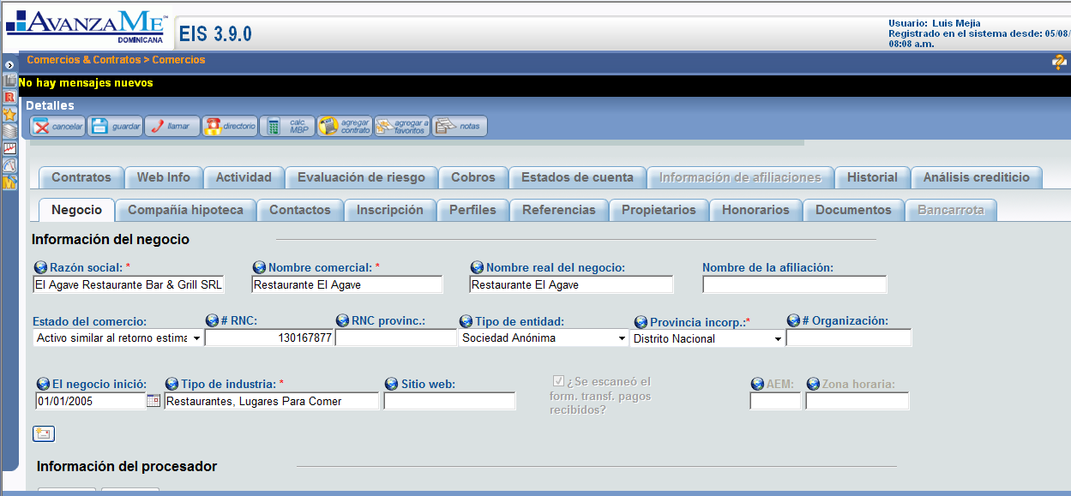

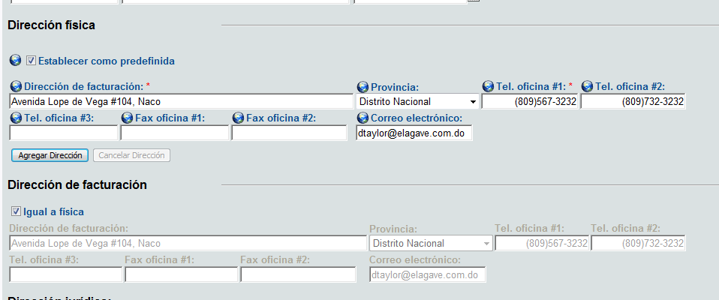

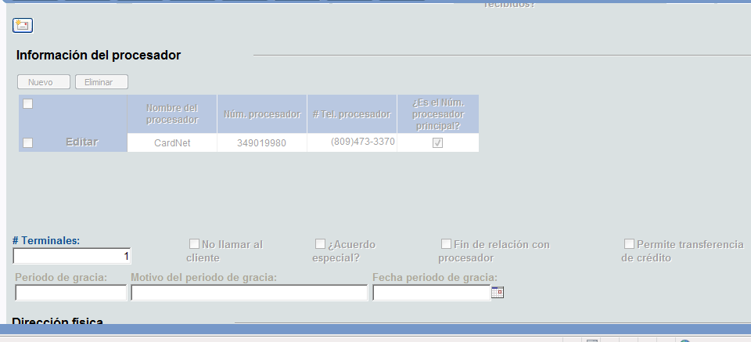

# Landlord Tab

This is the tab that contains the information of the landlord, if it applies. If the business owns the local, then this tab should be empty.

It contains these fields:

* Type of property
* Landlord Company Name
* Landlord Name
* Telephone Number
* Cell Phone Number
* Email
* Address  
  City
* Monthly Rent Amount

Below this should be a copy of the script from the Landlord verification task and all the answers that were filled in (if the contract workflow has been completed).

Our current Landlord tab looks like this:

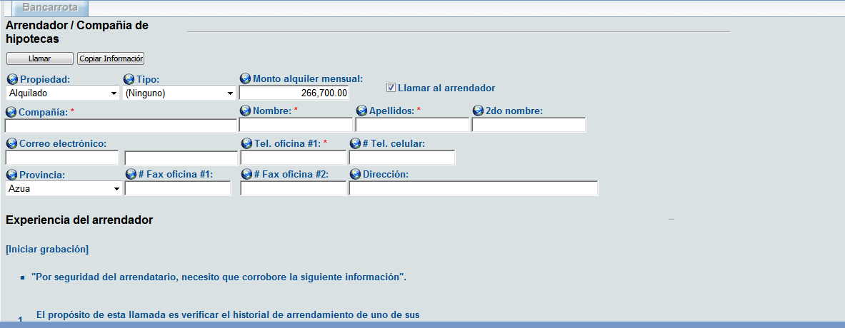

# Contacts Tab

This is where we store all the information regarding contacts of a Merchant. A contact is any person within the business of the Merchant that we can call for information. It could be an owner or not.

It contains these fields:

* Name
* Last Name
* ID
* Date of Birth
* Position
* Address
* City
* Province
* Email
* Telephone Number
* Cell Phone Number

In this screen we should be able to add and delete Contacts.

Our current Contacts tab looks like this:

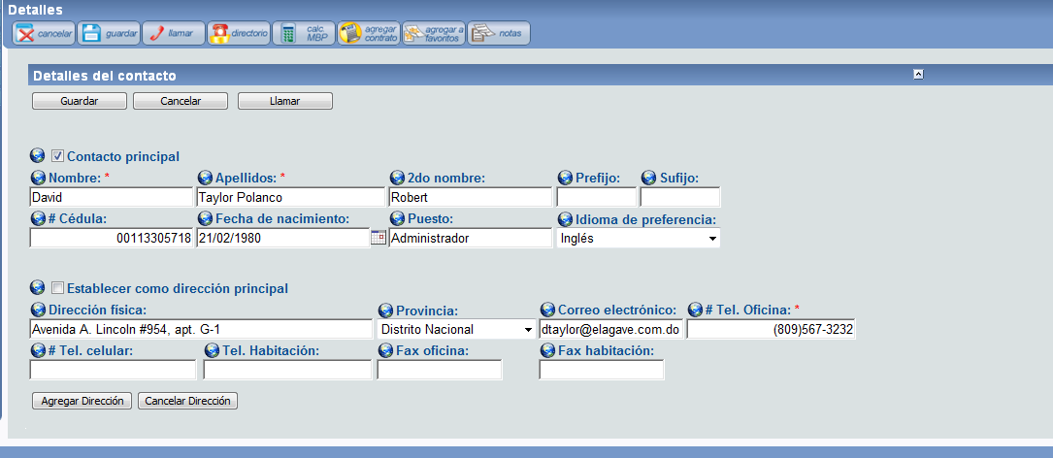

# Owners Tab

This tab is exactly like the Contacts tab except it needs to add a couple of fields:

* Name
* Last Name
* ID
* Date of Birth
* Position
* Address
* City
* Province
* Email
* Telephone Number
* Cell Phone Number
* Date became Owner
* Authorized to sign the contract (checkbox)

In the same way, we should be able to add and remove owners here.

# Profiles

This is the tab that contains information about the credit card affiliates and volumes.

It should have the following fields:

* Gross Yearly Sales
* Average monthly transactions (number of tickets per month)
* Average Monthly Credit Card sales: If the Merchant has an active contract this field will be calculated with the payments. For example, if a merchant is paying 10,000 every month and the retention percentage of his contract is 10%, then his monthly sales must be 100,000 (10,000/10%).
* Average used in the Calculator: This is the average credit card sales that were used in the calculator when the offer was made (if the Merchant has a contract).
* Monthly credit card sales as calculated by our system (if the merchant has an active contract) detailed month by month.
* Monthly credit card sales received from the Processor companies detailed month by month.

In this screen it would be convenient to have a drop list in the top that would let us choose between VisaNet and CardNet or both, and then show just the information concerning the selected option. For example, if we choose VisaNet, the fields will be filled only with VisaNet information, if I select CardNet only with CardNet information and if I select both, with all the information we have.

Our current Profiles tab looks like this:

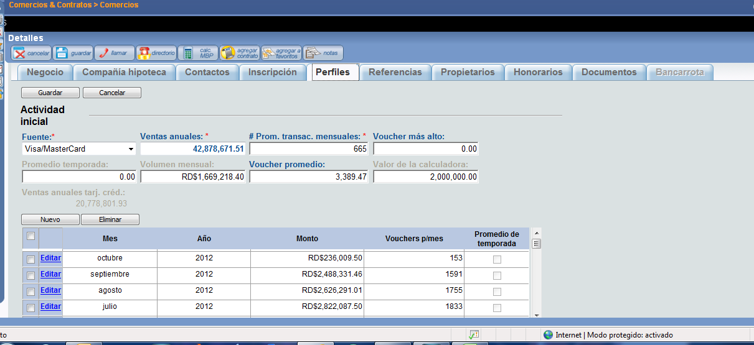

# Documents Tab

This is a list of all the documents uploaded in the workflows. It should let us upload and delete documents right in this screen and it should show the date and user that uploaded every document.

The documents are:

* Legal Documents of the Company (PDF, JPG, GIF, PNG, DOC)
* Commercial Name Verification Screenshot (JPG, PDF, PNG, GIF)
* RNC Screenshot (JPG, PDF, PNG, GIF)
* ID or Passport (JPG, PDF, PNG, GIF)
* Lease Contract or Land Title (PDF, JPG, GIF, PNG, DOC)
* Null Check (JPG, PDF, PNG, GIF)
* Bank Statements (PDF, JPG, GIF, PNG, DOC, XLSX)
* Payment Receipt (PDF, JPG, GIF, PNG, DOC)
* Payment Agreement (PDF, JPG, GIF, PNG, DOC)

# Activity Tab

This is the tab where we see all the payments the Merchant has done. You can organize this however you want, as long as we get to see in detail every financial activity in the Merchant, and organize it in a daily and monthly way.

It could look like this:



These fields should make more sense once we work through the Finances Module.

# Statements Tab

This is the tab where we generate the statements for the client. We will provide you with the correct format, but the way it works is we select a range of dates and then we click one of two buttons. The first button will be “Generate Statements” which will bring up a pop up with a PDF file of the statements. The second button will be “Send Statements” which will automatically send the statements from the chosen range of dates to the Merchant’s email address along with a corresponding script that we will write.

Also in this tab is where we can generate the fiscal invoices, just the same method as the statements.

Apart from this manual generation, the system should automatically send the statements to the client on the first and 16th of every month. Also, the fiscal invoices (we will provide you with the correct format) will be sent along with the statements.

The statements look like this:

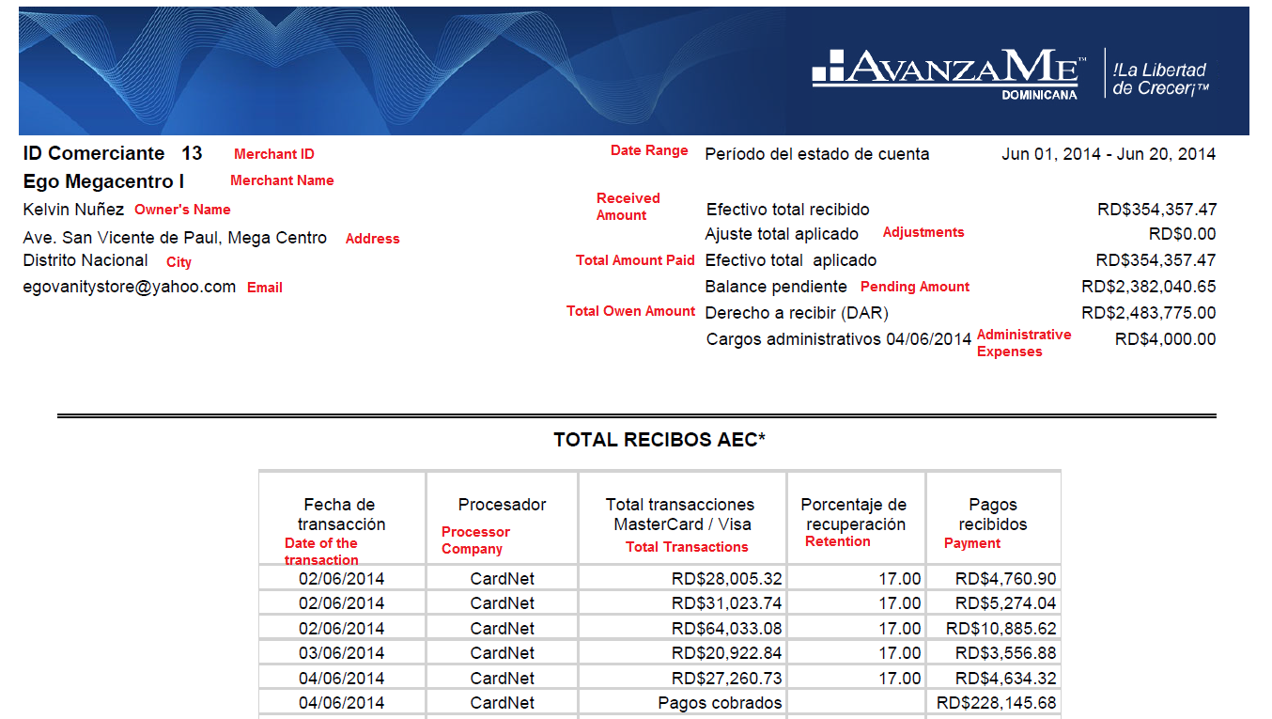

In red you’ll find the translation for every field. Some of these fields won’t make sense until we go through the Finances Module.

And this is how the Fiscal Invoices look:

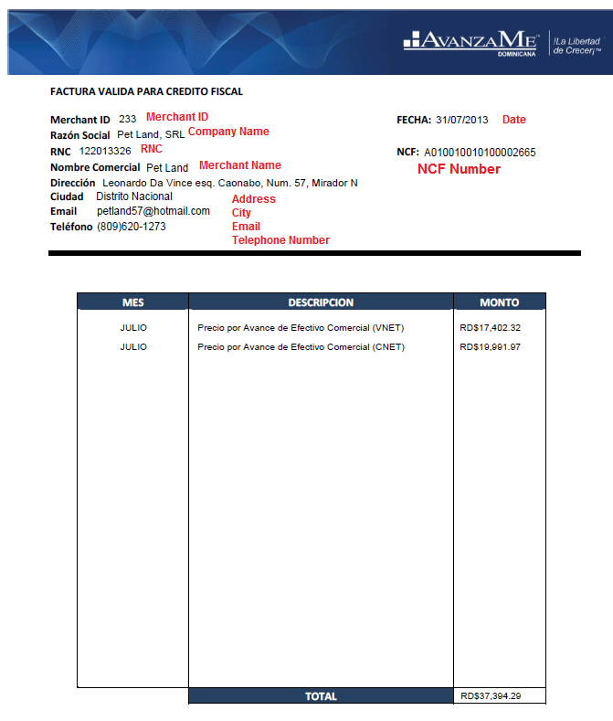

The NCF number is a sequential number, once the system is running we will tell you from what number to start and from then on the system assigns the numbers sequentially.

Again, it won’t make sense until we go through the Finances Module.

# History Tab

This tab should show a log of all the changes in every field or status of the Merchant.

Risk Evaluation Tab

This tab should let us access all the generated Datacréditos as well as keep a list of every score the system has ever given the Merchant.

# Contract Tab

This tab contains information about every contract the Merchant has ever had. It should show us a list of all the contracts with the parameters and the date they were funded. If we click a contract, it should popup a different screen with different tabs.

The list of contracts could look like this:



I believe you’re familiar with every field, except for “Real Time” which is the projected time the merchant will pay the contract in. For example, the offer was agreed to be paid in 8 months, so if he has to pay 175,000 in 8 months, then he would have to pay 21,875 per month to pay the contract in full in 8 months. But if he’s been paying 23,150 per month, then he will be projected to pay in 7.56 month (175,000 / 23,150). This is how the Real Time of the contract should be calculated, except that the calculations should be done based on what he has to pay *per day* and what he’s been really paying every day.

This new pop up should contain these tabs:

### General Tab

In this tab is the general information of the contract.

The fields are:

* Contract Number
* MCA Amount
* Owed Amount
* Contract Status
* Funding Date
* Scanned contract and IOU (this button should show us a PDF of the contract and IOU)
* Retention Percentage (This field should be editable according to permissions and it should keep a log of changes)
* Administrative Expenses (This field should be editable according to permissions and it should keep a log of changes)

### Contract Activity tab

This is much like the previous activity tab, but for this specific contract.

### Sales Representative Tab

Here we should be able to add and remove Sales Reps associated with the contract.

### History Tab

This is a log of all the changes in every field.

Our Contract tab looks like this:

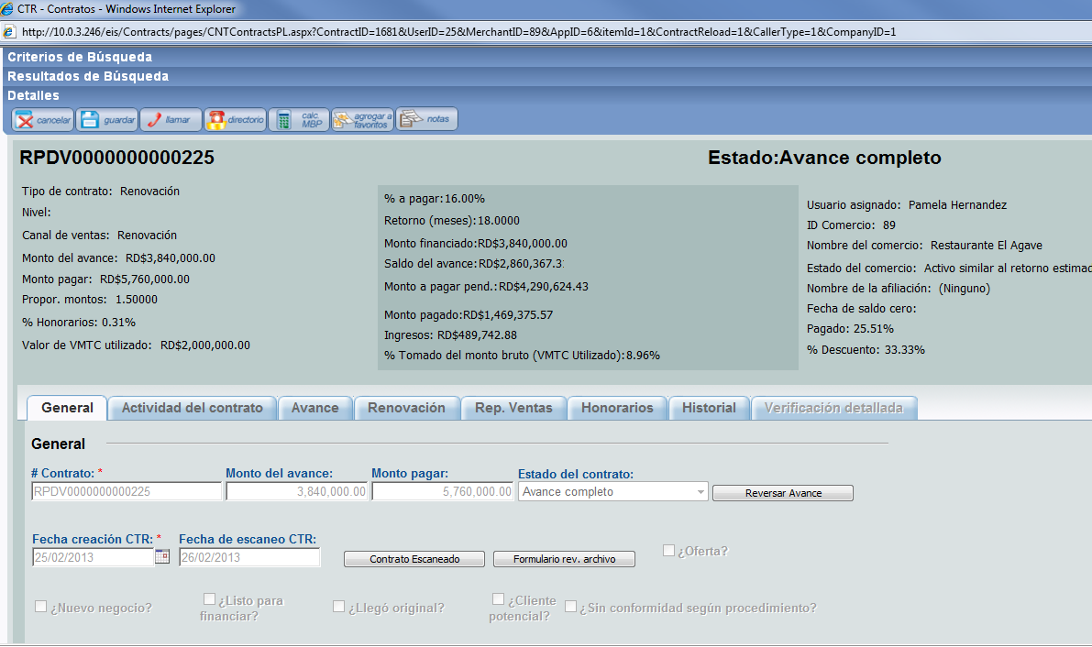

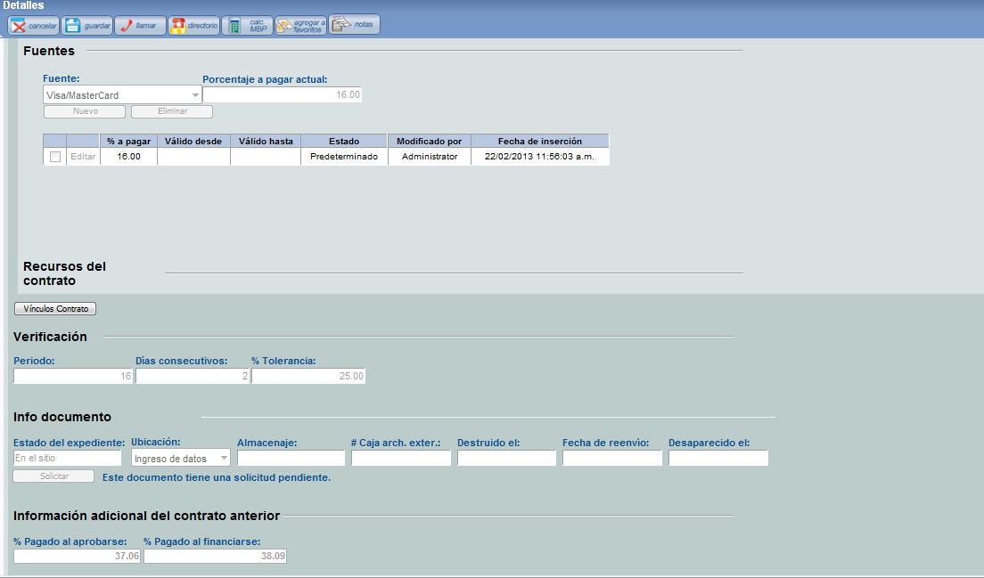

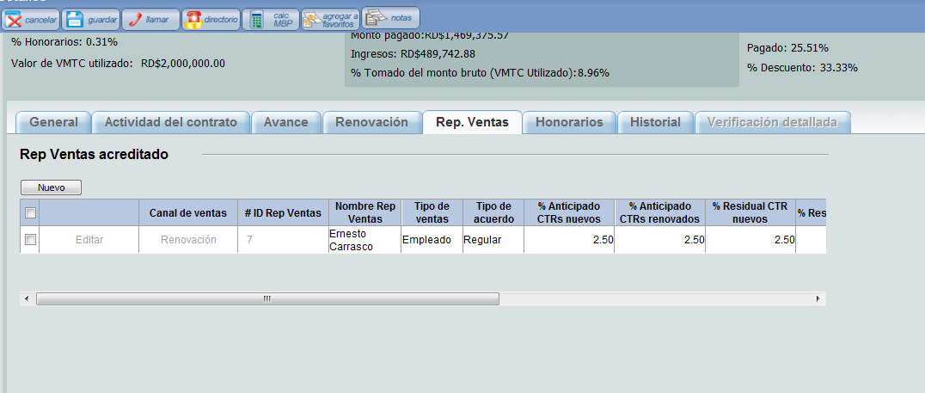

# Collections Tab

In this tab we will see information if the Merchant has a contract (or has had a contract) in collections. The details of this tab are in the Collections workflow document.

# Affiliation Tab

As we have specified before, a company or owner might own several different business which are created as separate Merchants in our system. But we still need a way to link them, so an affiliation is a link that exists between all the Merchants that have the same RNC number (this means they are owned by the same company) or the same Owner ID (which means they are owned by the same person).

This button will pull the Merchant’s affiliation screen, which could look something like this:



As you can see, there are two tabs. One tab is for the merchants with the same RNC and the other is for the Merchants with the same Owner.

There should be two boxes of information, one for all the merchants with the same RNC or Owner as the Merchant we are currently in that have Active Contracts and another box for all the affiliations that don’t have Active Contracts.

For the inactive contracts we need a button that will let us request the CC volumes for the merchants to the Processor Company. If we request the volumes, this list should show a Volumes Status that will be marked as pending until the Processor Company sends the requested volumes.

# Final Notes

The Merchant screen needs to have the following buttons:

* Save Button: To save any change made to any field.
* Cancel Button: To erase any change made.
* Call Button: With a list of all the stored telephone numbers in the Merchant, including owners, contacts, landlord and business numbers.
* Notes Button: A button to access the Notes application to write and read notes.

Once we enter a Merchant screen, the first seen we need to see on top is an information box on top with the essential information:

* Merchant ID
* Merchant Name
* Amount left to pay of the current contract
* Date of the last activity (this is the date of the last payment we received)
* Merchant Status

# On Status

In the system there are going to be three sets of status: the Merchant status, the Contract status and the Collections status. The contract status has been specified in the Contract Workflow document.

## The Merchant status

The Merchant status will change depending on the status of the active contract. If the Merchant has an active contract that is paying over 20% faster than expected when calculating the offer, then the Merchant status will be marked as “Contract being paid faster than expected”. If the active contract is being paid over 20% slower than expected, the Merchant status will be marked as “Contract being paid slower than expected”. If the contract is being paid within +-20% then it will be marked as “Contract being paid on time”.

Now, how will we know how fast or slow the contract is being paid? When the offer is calculated, we set an expected time for the offer to be repaid in. For example, we could lend $100,000 with a 1.3 price and expect the full $130,000 to be paid in 8 months. That means that we expect the Merchant to pay the contract in full in around 243 days (8 * (365/12)). For that to be true, he’d need to pay around $535 every day ($130,000 / 243). Now let’s say that the Merchant, instead, is paying $500 every day, it would take him 260 days to pay the contract in full, which is about 8.55 months, so he’s paying 6.88% slower than he should.

The time calculated in the offer is called the **Expected Turn** and the actual time the contract is being paid in is called the **Real Turn**.

If we don’t receive any payment for an active contract for 4 days then the Merchant status will be “Investigation”. And, if an active contract has not received any payment for 30 days, the Merchant status will be marked as “Collections”.

If there isn’t any active contract (either because the latest contract was paid in full and not renewed or the latest contract was marked as Written Off) then the Merchant will be marked as “Inactive”.

## The Contract Status

At first, the contract status will change according to the stage the contract is at in the workflow. Once the contract has been funded, the contract will be marked with the status “Funded” until the contract has been paid off in full. In that case, the contract status will be “Closed – Paid”. If the contract has not received any payment for the last 180 days, then the contract will be marked as “Written Off” and the Merchant will be inactive.

## The Collections status

When a Merchant has been marked with the “Collections” status, the default Collections status (which we will see in the Collections screen) will be “In Investigation”. If we have an active Payment Agreement with the Merchant, then the Collections status will change to “Payment Agreement”. If we have assigned the case to an external lawyer then the Collection status will change to “Collections – External”. All this will be done through the Collections workflow.